About Workato
Workato delivers enterprise infrastructure for the agentic era, redefining iPaaS and helping enterprises unify data, applications, processes, and AI into a single, governed platform. A leader in Enterprise MCP and trusted by 50% of the Fortune 500, Workato’s cloud-native architecture connects every application, data source, and process to power real-time orchestration at scale. With enterprise-grade security and continuous innovation at its core, Workato provides the trusted foundation for organizations to automate with confidence and operationalize AI across the business. To learn more, visit www.workato.com.
Blog: https://www.workato.com/the-connector/
Product Hub: https://www.workato.com/product-hub/
LinkedIn: https://www.linkedin.com/company/workato
Twitter/X: https://twitter.com/workato

Get Started
- To trial Workato’s AI features and start on AI projects, create a Developer Sandbox Account.
  - Workspace has no expiry date, and is limited to 50,000 free usage credits - more than enough to build several use cases over an entire year.
  - Education partners can request for more credits by providing the Workspace ID of users.
  - All AI-native and Enterprise features are present, including
    - AIRO Copilots (Docs)
    - Intelligent Document Processing (IDP) (Docs)
    - AI by Workato connector (Docs)
    - Agent Studio for building Genies (Docs)
    - Workato GO front-end interface (Docs)
    - Workflow apps (Docs)
    - API Management (Docs)
    - Data tables (Docs)

Set Up Your Developer Sandbox Account
1. Open this sandbox link: https://www.workato.com/sandbox , then click on “Start Building Free

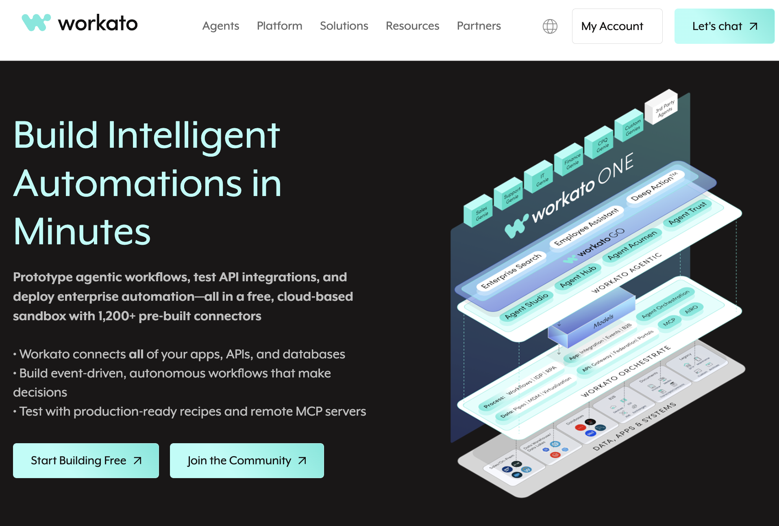
2. Fill in the rest of the info and click Create your account. You have the option to sign in using your Google or GitHub account too. Students and educators are advised to sign in using your school emails.

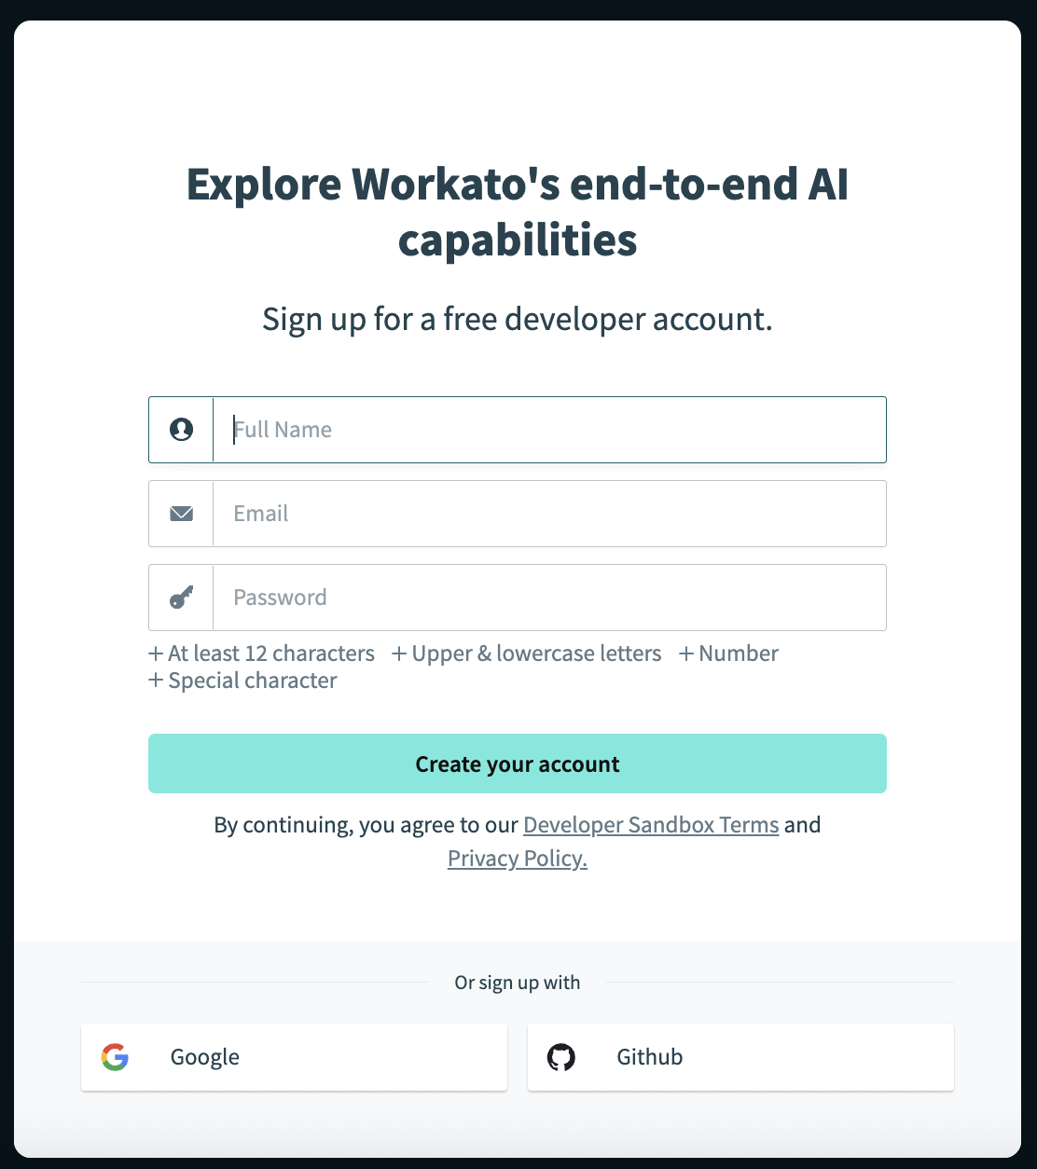
3. Look for an email titled, Activate your account, sent by admin@trial.workato.com. Check your spam folder if you do not see it in your inbox.
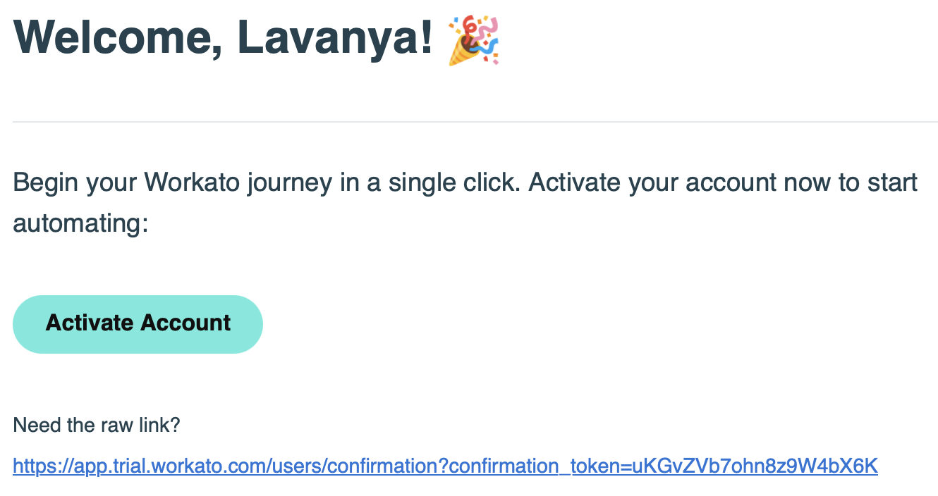
- Click on the activate account button in that email or copy and paste the link provided into your browser. You will be redirected to the sign in page, where you will need to key in your password

4. Next, click Get started
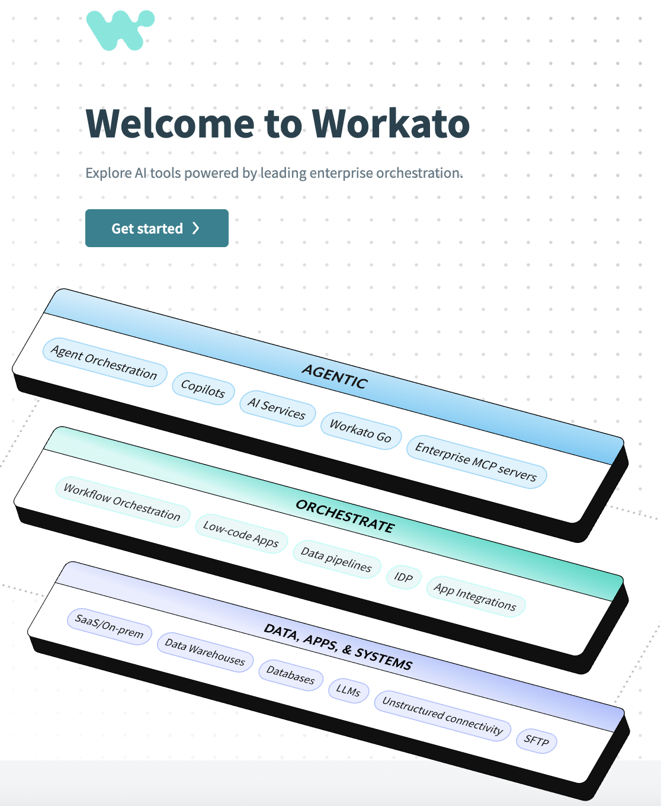

5. To build your own AI Agent on Workato’s Agent Studio, click on Create a genie. Alternatively, start by building a recipe or setting up an MCP server.
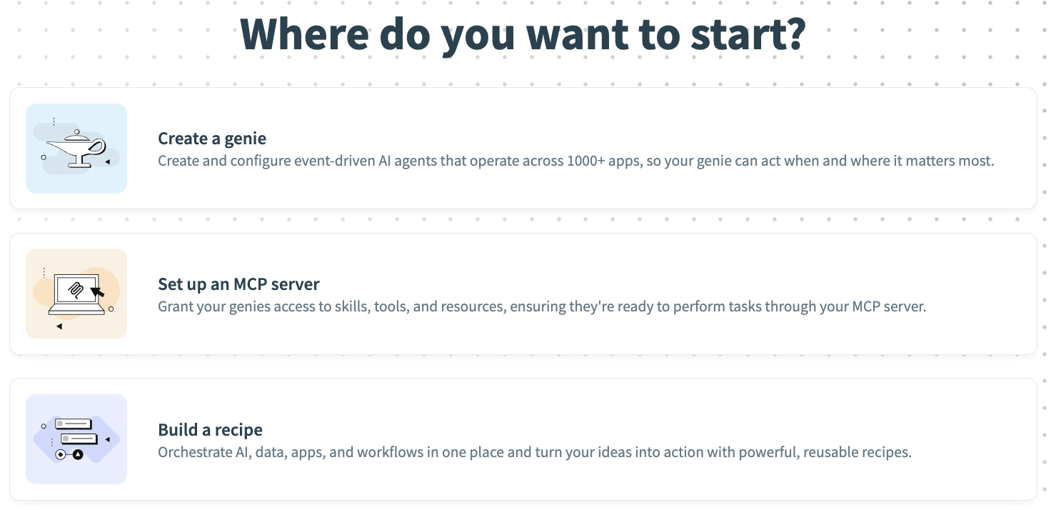
5. To build your own AI Agent on Workato’s Agent Studio (recently renamed to AI Hub), click on AI Hub on the left panel. Then click Create genie. Alternatively, start by building a recipe or setting up an MCP server.
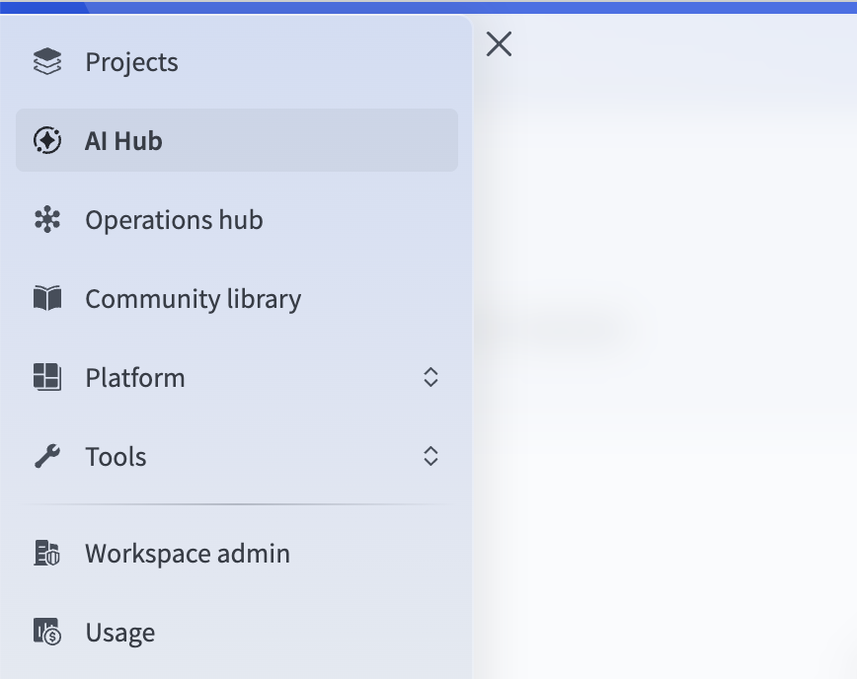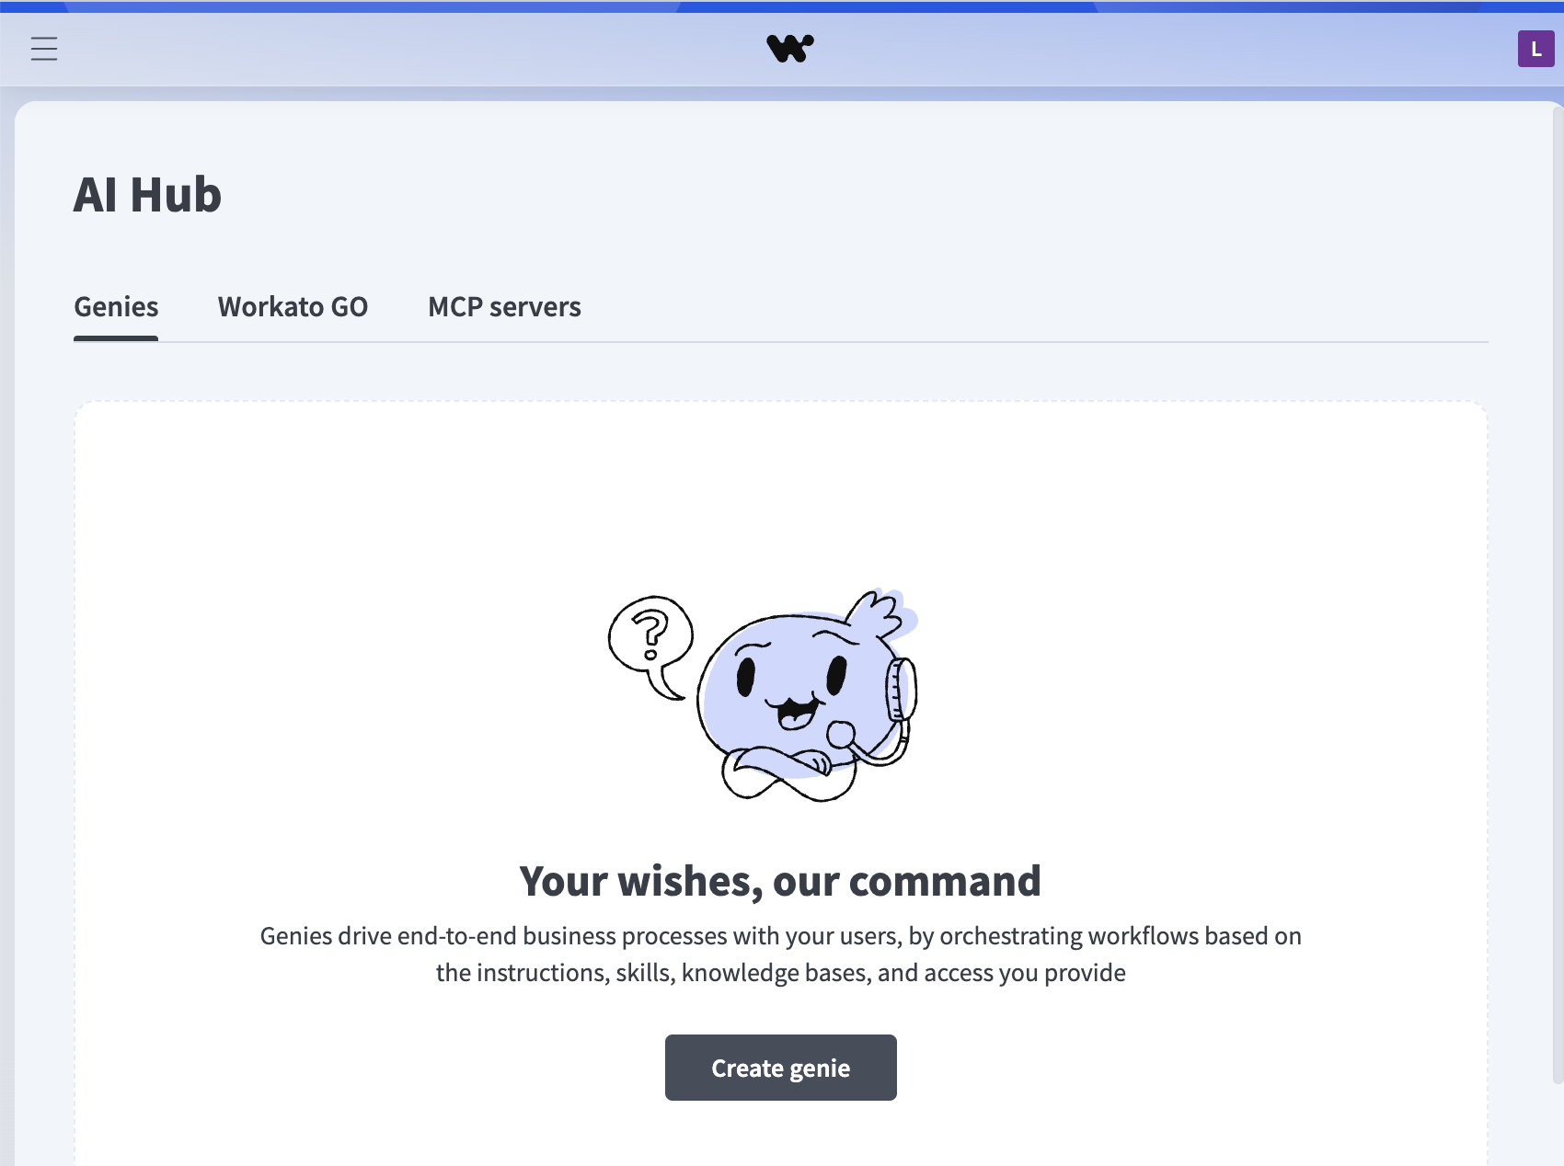
🎉 You now have a Developer Sandbox account! To sign in to it again, use this link: https://app.trial.workato.com/users/sign_in_trial

To pursue your Workato Academy certifications using your Developer Sandbox account, follow the below steps:

- Click "Login" on the top right corner of the Workato Academy page: https://academy.workato.com/learn
- When asked “Where is your account based?”, scroll down and select "Developer Sandbox"
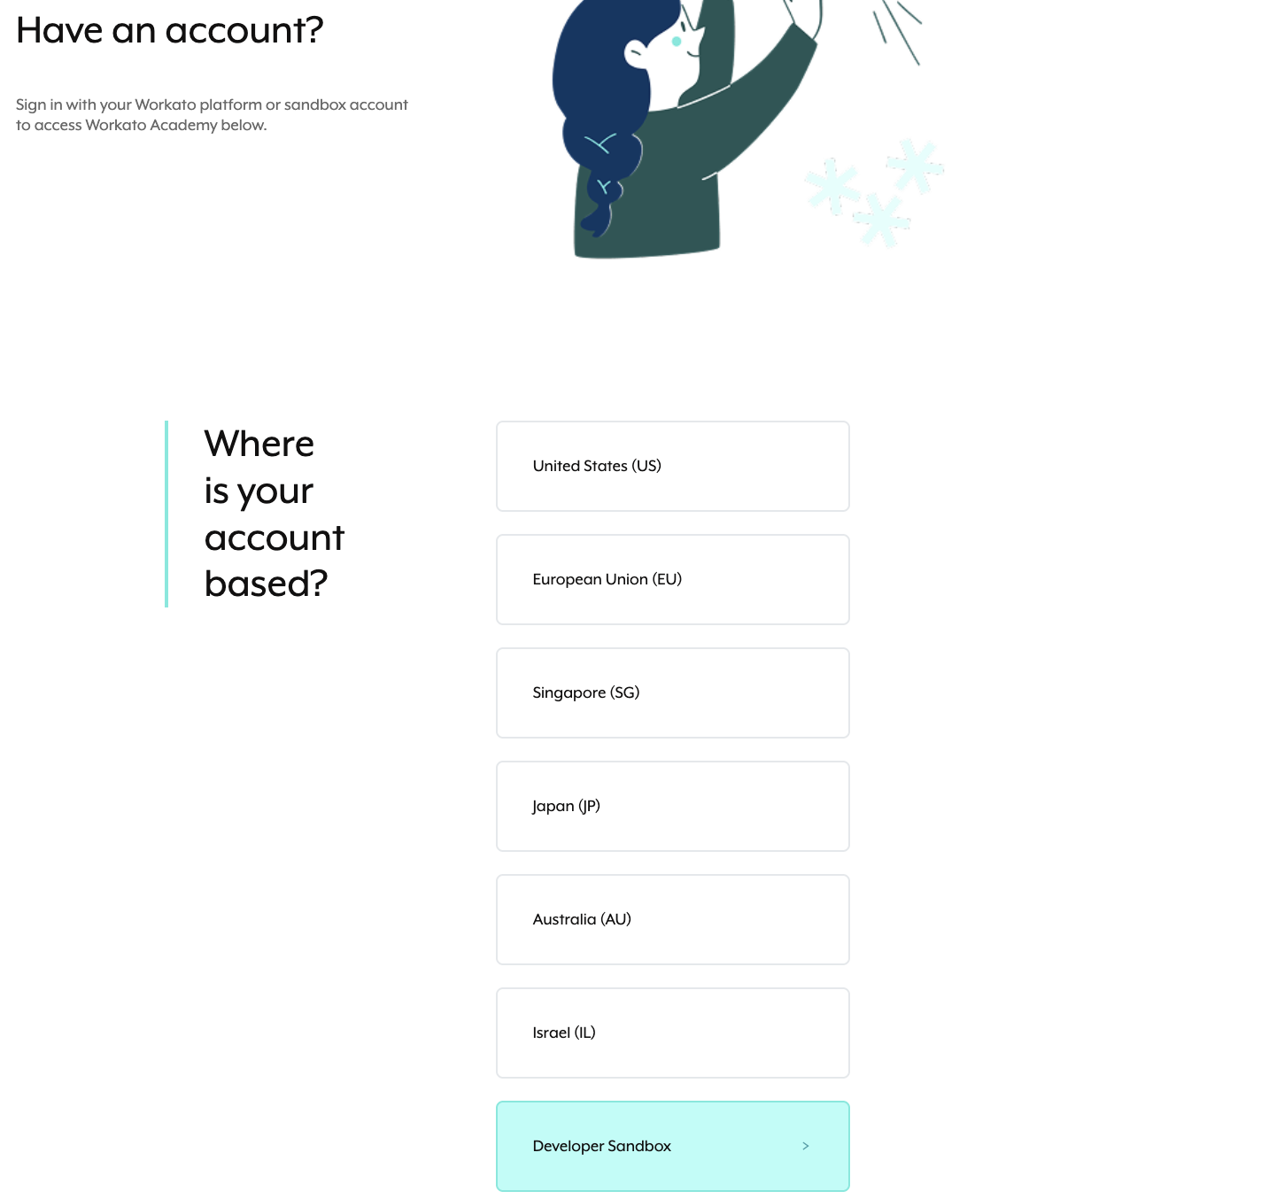
- Once you key in your sandbox credentials, you will be prompted to adjust the time zone accordingly
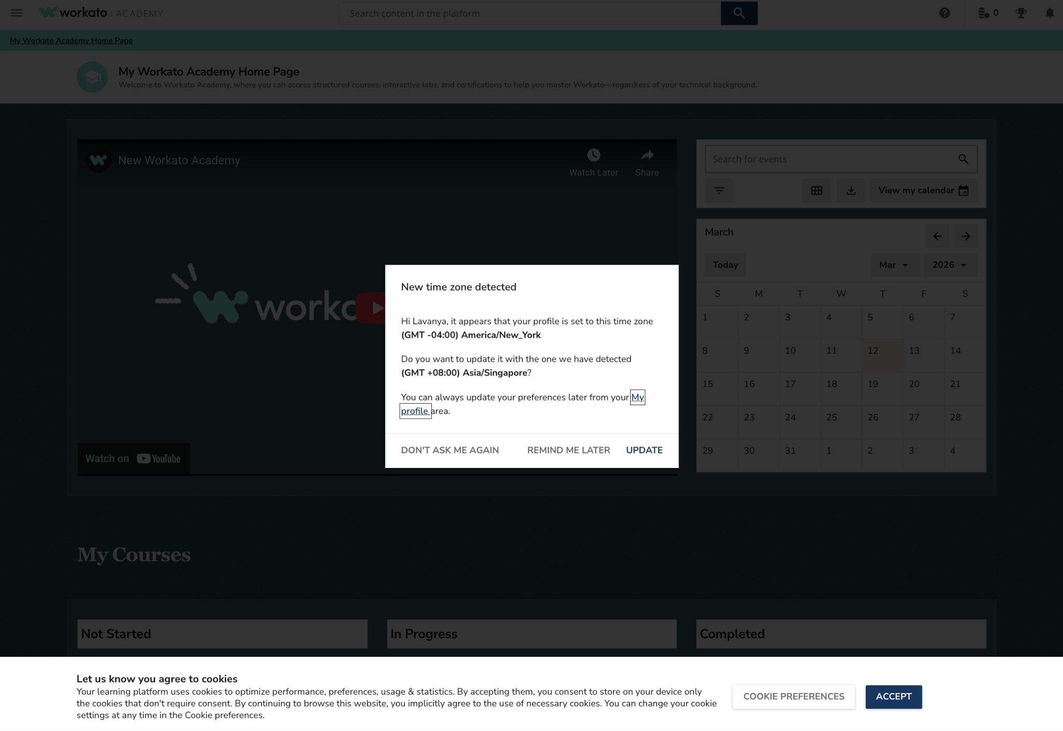

Get Certified
- Learners can sign in to the Workato Academy here. If you already have a developer sandbox account, you can login with those credentials.
- As a start, secure these certifications by registering using a corporate/student email.
  - Foundations 1 (~3 hours): Covers the core platform architecture and solution design frameworks, in addition to basic recipe design
  - Agentic AI Basics (~30 min)
  - Enterprise MCP (Model Context Protocol) (~1 hour)
  - Introduction to Agent Studio (~1 hour)
- You can then progress to Workato’s Foundation 2 course (~6 hours), which is highly recommended for intermediate learners who wish to explore capabilities across the pillars of Workato’s BOAT (Business Orchestration and Automation Technologies) framework — iPaaS, Data Orchestration, API Management, Business Process Automation (BPA), and AI Agentic workflows.
- Completing the above certifications is a prerequisite to those seeking to earn the highly sought-after Integration Developer Certification, which is exclusively open to advanced builders.
- Don't forget to add your certificates to LinkedIn by navigating to "My Profile" at the top right hand corner of the academy.workato.com page and clicking "Add to LinkedIn"

All courses include guided lab exercises that introduce key concepts through hands-on practice.

Get Inspiration from the Community Library 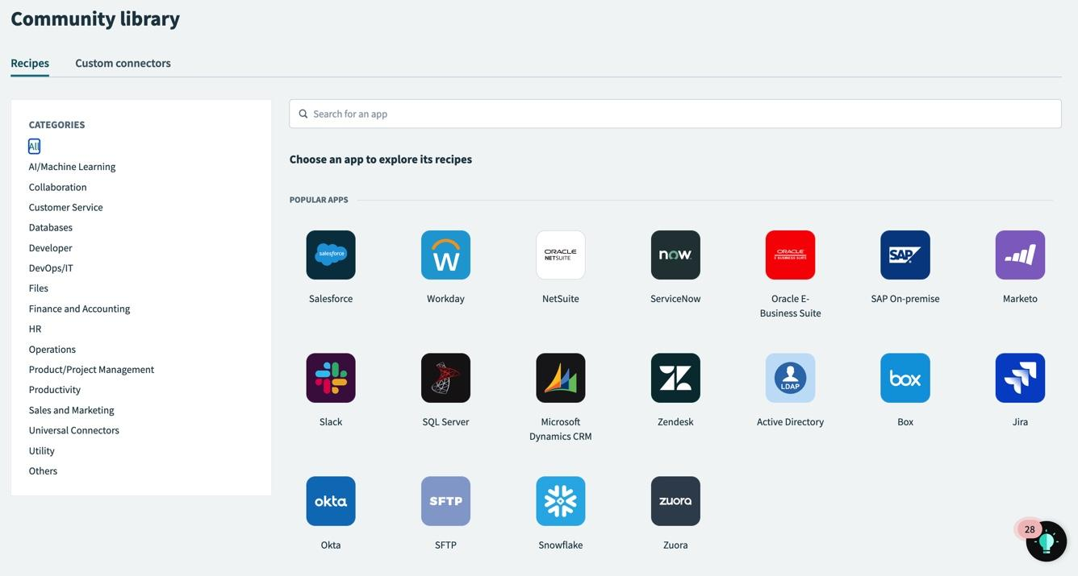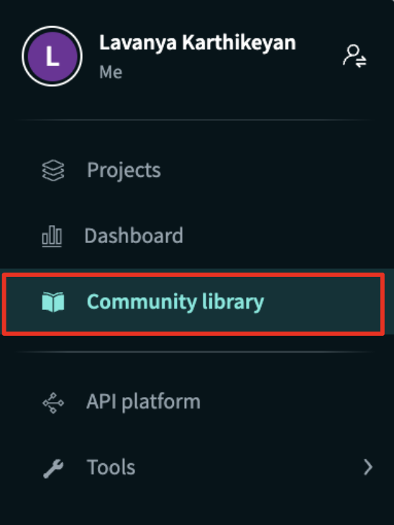
Once you have logged in to your Workato account, click on your initial on the left. Then click on Community Library to access it.

Useful Resources
For Courses and Certifications - Workato Academy: https://academy.workato.com/
For Help - Workato Success Centre: https://support.workato.com/en/support/home
For Documentation on Platform / Features - Workato Docs: https://docs.workato.com/
For Articles / Reports - Workato Connector Blog: https://www.workato.com/the-connector/
For Case Studies / Other Resources - Content Library: https://www.workato.com/resources
For Questions: Write to lavanya.karthikeyan@workato.com or reach out to a mentor from Workato

Appendix

How to locate your Workspace ID

You will need to share your Workspace ID with Workato if you need any feature changes to be made to your sandbox workspace.

- To locate this ID, click on the list icon at the top left of the screen.

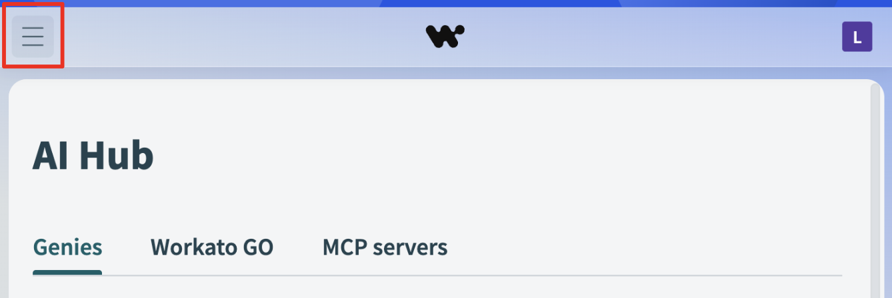
- Then select Workspace Admin
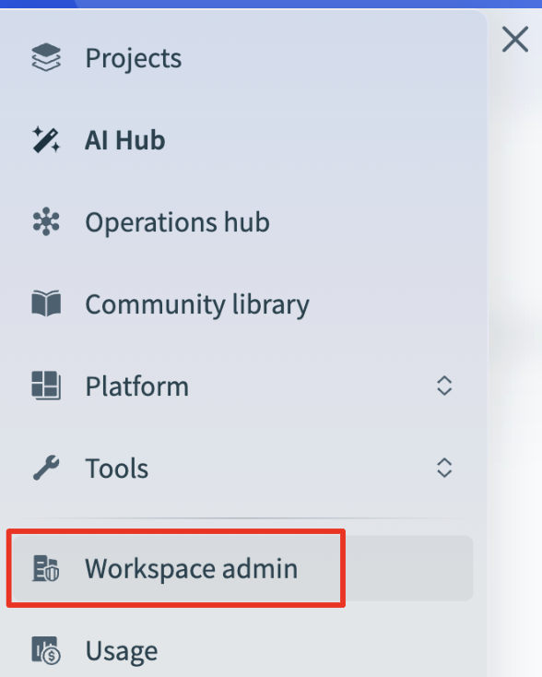
- Click on the Settings tab
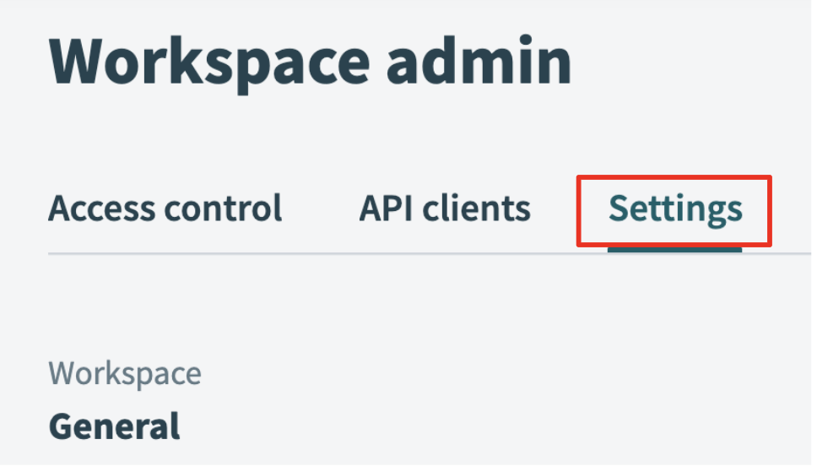
- Scroll down to find your Workspace ID
